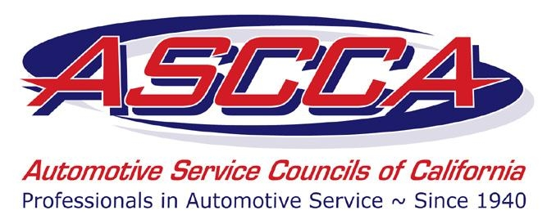

The Automotive Service Councils of California Chapter 28 is inviting local Automotive Repair Shop Owners & Technicians to attend our Membership Drive/Vendor Fair at

Tilletts Automotive
1426 Petaluma Hill Road
Santa Rosa, CA 95404
August 24th, 2022
6-9 pm.
Dinner starts at 6pm

Special Guest Speaker:
Carolyn Coquillette, President of ASCCA
Founder and CEO of Shop Ware
Owner of Luscious Garage
Come find out what we are about and learn more about the ASCCA Advantage and enjoy a free dinner. Good to be back in person.

Dinner Sponsored by BG Products
Jason and Scott will discuss induction/intake services on both standard and direct injection applications. Also, big advantage of using MOA/EPR products on GDI engines.

Visit with ASCCA Benefit Providers, Educational Seminars Institute, Armstrong Insurance, California Employer’s Services, Shop Ware, Napa Auto Parts, and more
Special thank you to Mail Shark for designing our mailers
This year
Don’t miss YOUR chance to win one of the many raffle prizes, including 4 $100.00 VISA Gift Cards!
Must be present to win.

R.S.V.P. to Bob at 707-546-2851, billsaer@sonic.net by 8-18-2022

